
Create ansible playbook to create ansible vault.
Step 1: Create Secret File
cd playbooks/
vi secret.yml
in secret.yml
user: admin
passwd: admin123
Step 2: Encrypt Secret File
ansible-vault encrypt secret.yml
Enter and confirm vault password.
Step 3: Create Playbook
vi vault.yml
edit vault.yml
Syntax to paste:
---
- name: Use Ansible Vault
hosts: all
become: yes

vars_files:
- secret.yml

tasks:
- name: Show vault data
debug:
msg: "User is {{ user }} and Password is {{ password }}"
Step 4: Run Playbook
ansible-playbook enter_vault.yml --ask-vault-pass
Enter vault password.
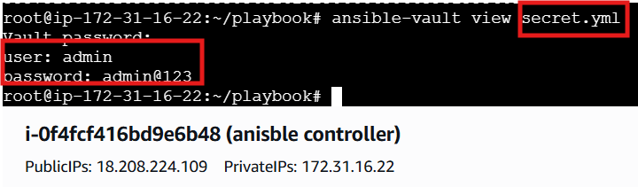
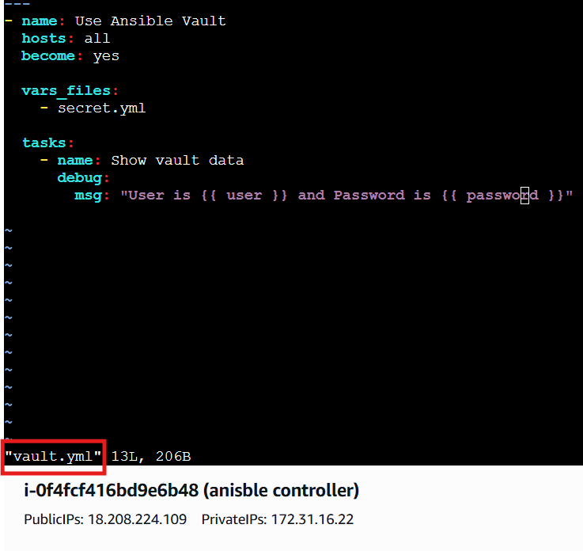
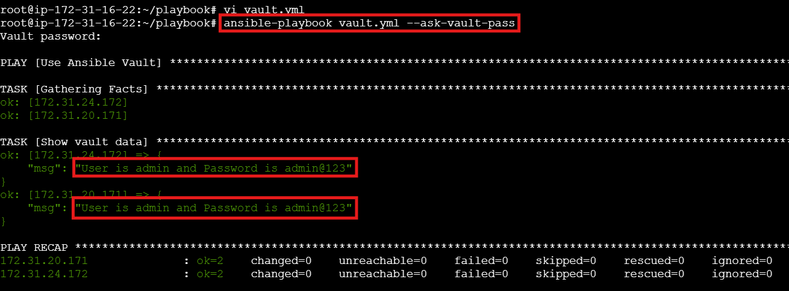

- Write a ansible playbook to install apache in linux and ubuntu machine by using when condition.
Step 1: Create Playbook
cd playbooks/
vi install_apache.yml
Step 2: Add YAML Code
apache.yml
Syntax::
---
- name: Install Apache on Ubuntu and Linux
hosts: all
become: yes

tasks:

# For Ubuntu / Debian
- name: Install Apache on Ubuntu
apt:
name: apache2
state: present
update_cache: yes
when: ansible_os_family == "Debian"

# For RHEL / CentOS / Amazon Linux
- name: Install Apache on Linux
yum:
name: httpd
state: present
when: ansible_os_family == "RedHat"

# Start service on Ubuntu
- name: Start Apache on Ubuntu
service:
name: apache2
state: started
enabled: yes
when: ansible_os_family == "Debian"

# Start service on Linux
- name: Start Apache on Linux
service:
name: httpd
state: started
enabled: yes
when: ansible_os_family == "RedHat"
Step 3: Run Playbook
ansible-playbook apache.yml
Step 4: Check Output
You will see:
- Ubuntu → apache2 installed and started
- RedHat → httpd installed and started
- Other OS → skipped
Example:
skipping: [host]
ok: [host]

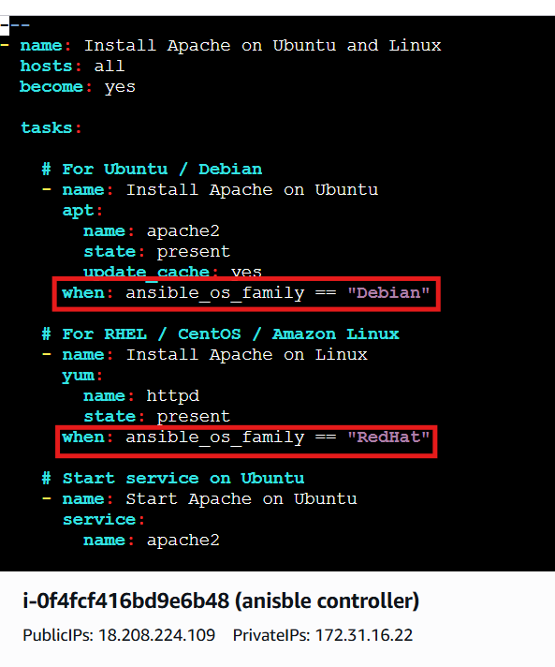
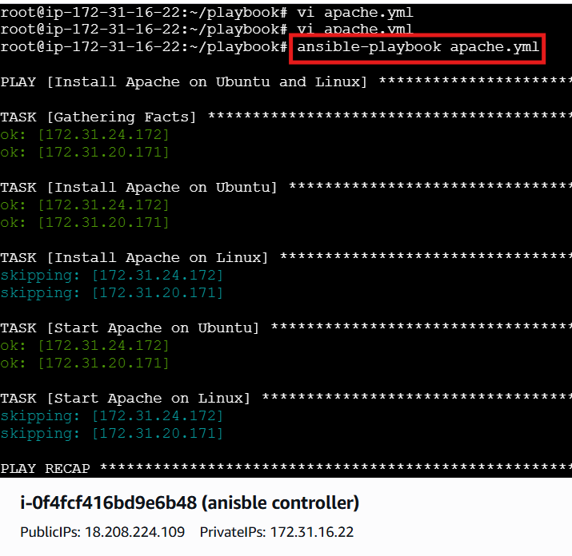
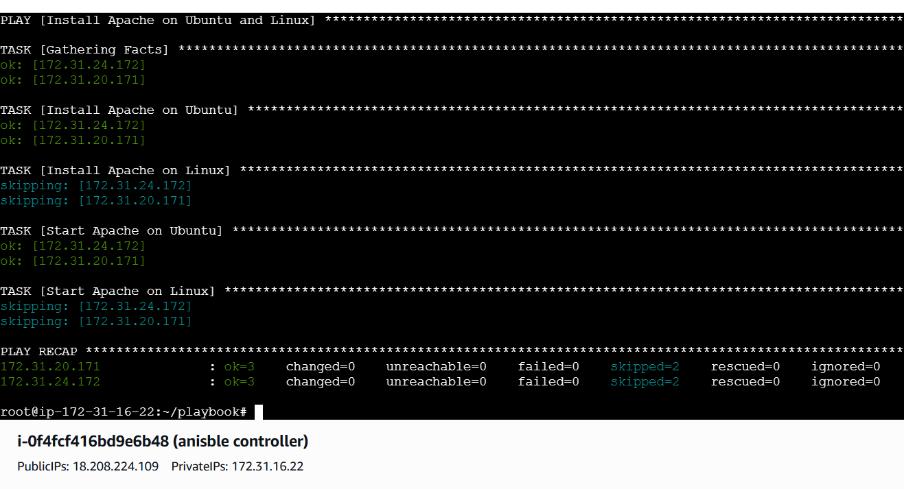

- Create ansible playbook using roles to configure LAMP stack
Step 1: Create Roles Directory Structure
mkdir -p lamp/roles/{apache,mysql,php}/{tasks,handlers}
Check:
ls lamp/roles/
You should see:
apache mysql php
Step 2: Apache Role
Create tasks file
cd lamp/roles/apache/tasks
vi main.yml
📄 lamp/roles/apache/tasks/main.yml
---
- name: Install Apache
package:
name: "{{ 'apache2' if ansible_os_family == 'Debian' else 'httpd' }}"
state: present

- name: Start and Enable Apache
service:
name: "{{ 'apache2' if ansible_os_family == 'Debian' else 'httpd' }}"
state: started
enabled: yes
Step 3: MySQL Role
cd lamp/roles/mysql/tasks
vi main.yml
📄 lamp/roles/mysql/tasks/main.yml
---
- name: Install MySQL Server
package:
name: "{{ 'mysql-server' if ansible_os_family == 'Debian' else 'mariadb-server' }}"
state: present

- name: Start and Enable MySQL
service:
name: "{{ 'mysql' if ansible_os_family == 'Debian' else 'mariadb' }}"
state: started
enabled: yes
Step 4: PHP Role
cd lamp/roles/php/tasks
vi main.yml
📄 lamp/roles/php/tasks/main.yml
---
- name: Install PHP Packages
package:
name:
- php
- php-mysql
state: present
Step 5: Create Main Playbook
cd lamp
vi site.yml
📄 lamp/site.yml
---
- name: Configure LAMP stack using roles
hosts: all
become: yes
gather_facts: yes

roles:
- apache
- mysql
- php
Step 6: Check Syntax
ansible-playbook site.yml --syntax-check
Step 7: Run Playbook
ansible-playbook site.yml
This installs:
Apache
MySQL
PHP
On all servers.
Step 8: Verify Services
Check Apache
systemctl status apache2
Check MySQL
systemctl status mysql
Both should be active (running).
Step 9: Test PHP
Create phpinfo file
echo "<?php phpinfo(); ?>" > /var/www/html/info.php
Open in browser
http://<SERVER_PUBLIC_IP>/info.php
You will see the PHP info page (like in image).

Final Folder Structure
lamp/
├── site.yml
└── roles/
├── apache/
│ └── tasks/main.yml
├── mysql/
│ └── tasks/main.yml
└── php/
└── tasks/main.yml

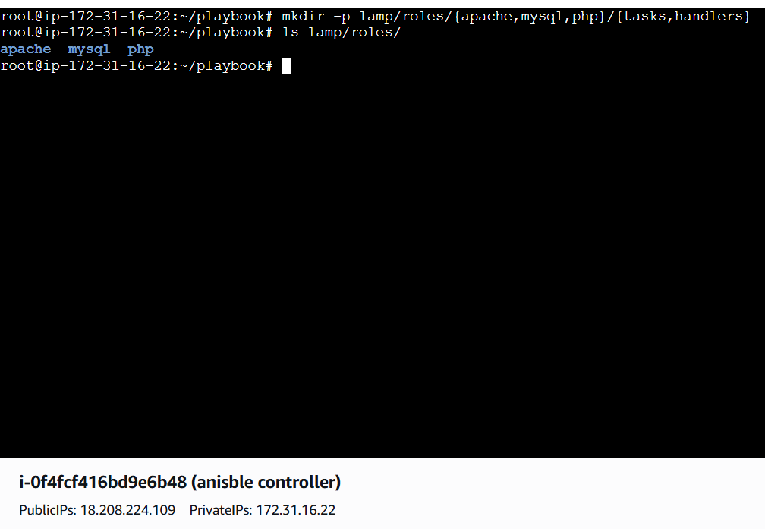

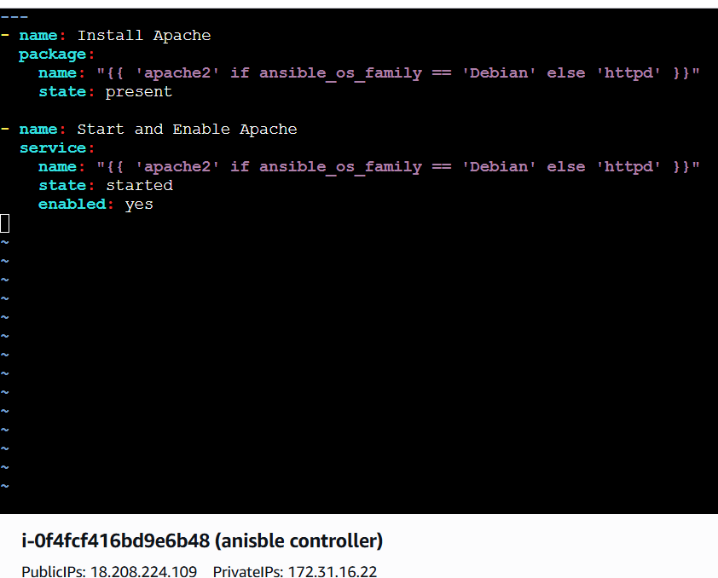

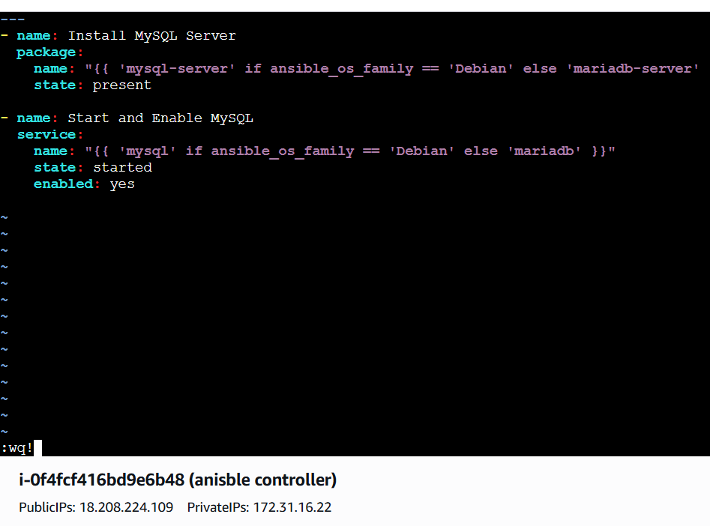
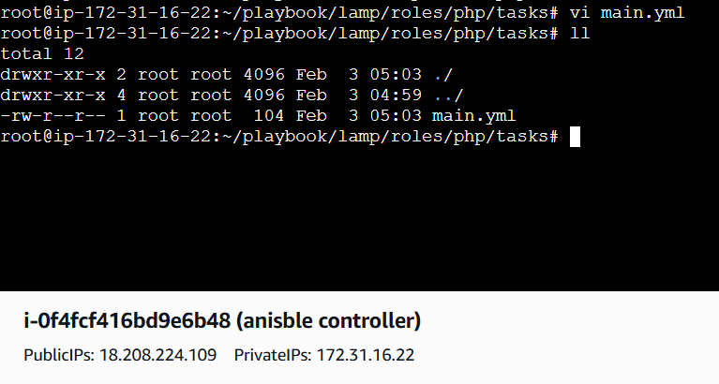
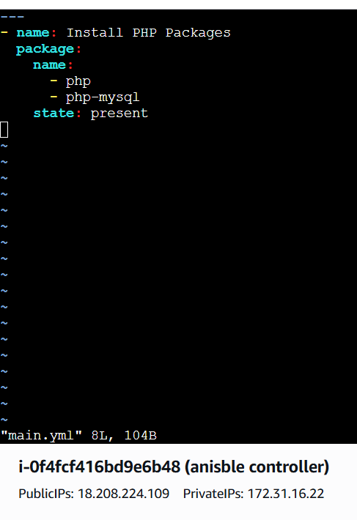

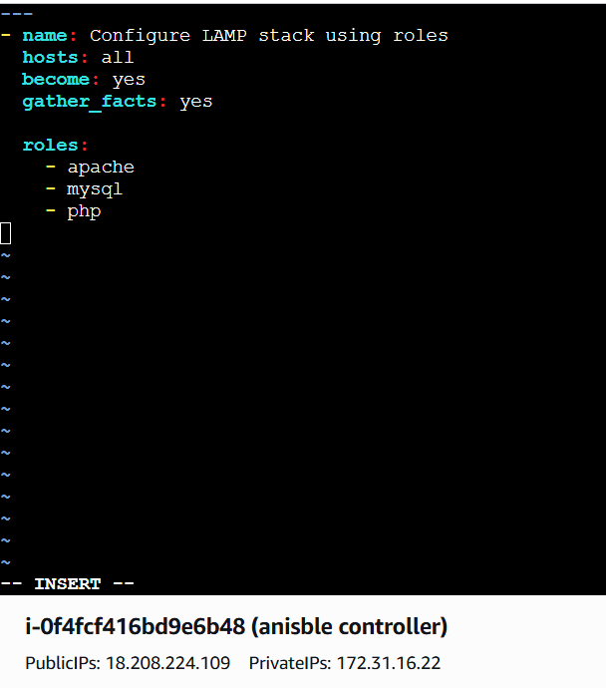
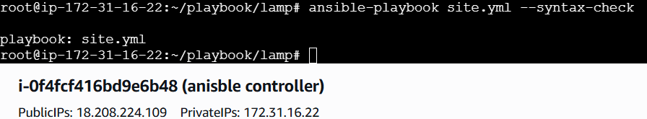

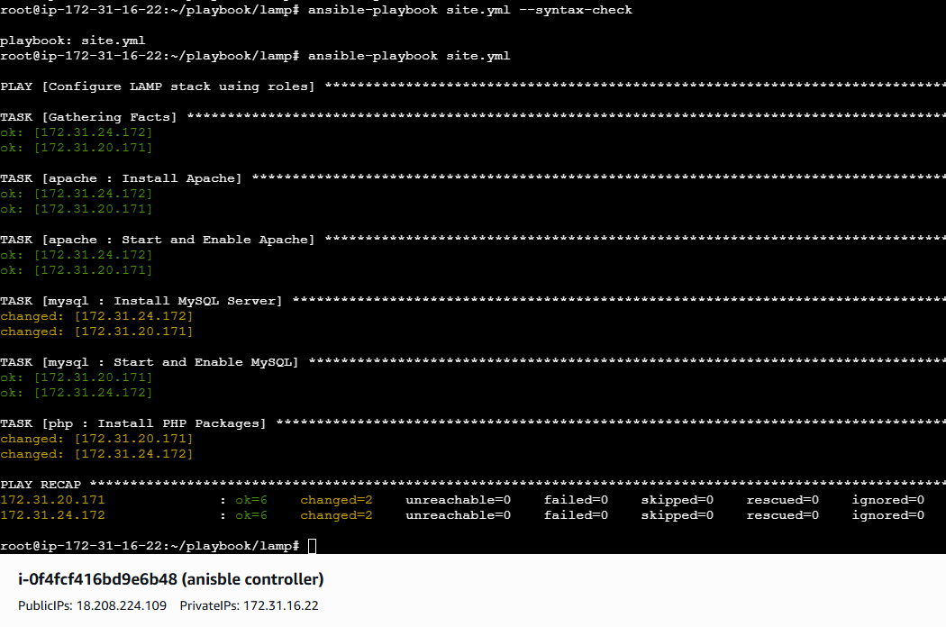
- Setup ansible AWX and explore the options.
Launch Ubuntu AMI
Instance type: c7i flex large
Storage – 20gib
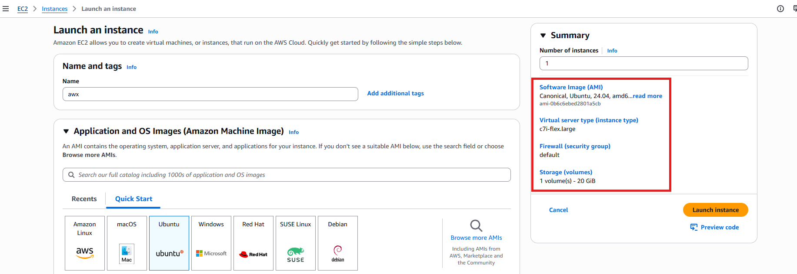
Update the required packages
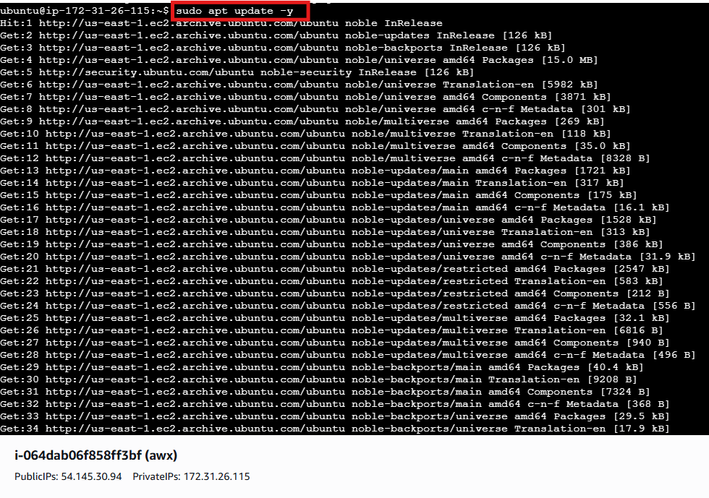

Install ansible
apt install ansible -y
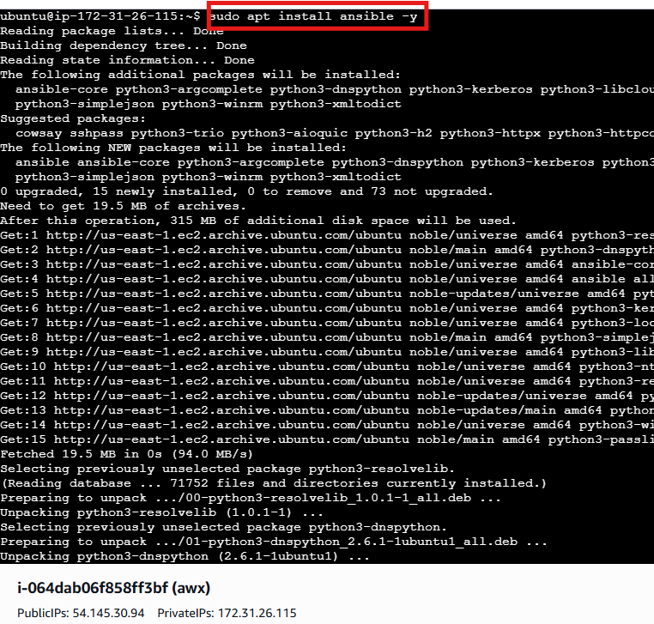

Install docker
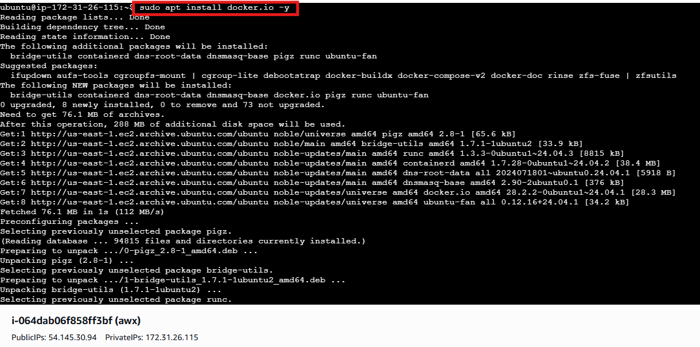
systemctl start docker
systemctl status docker
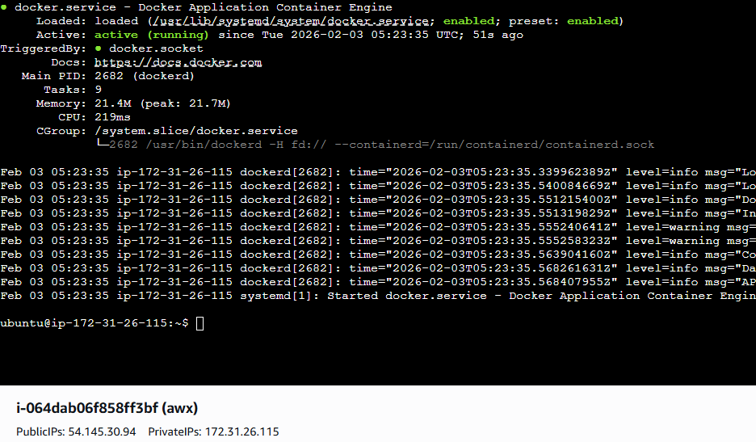

Install docker compose
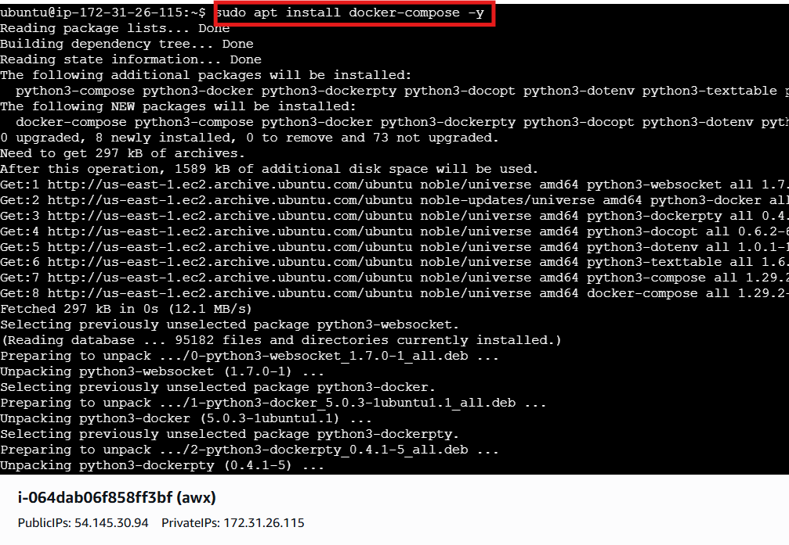
Clone the files
git clone -b 17.1.0 https://github.com/ansible/awx.git
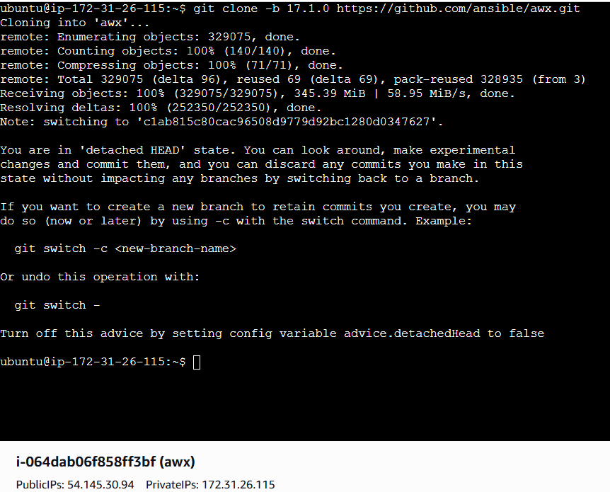
Cd awx
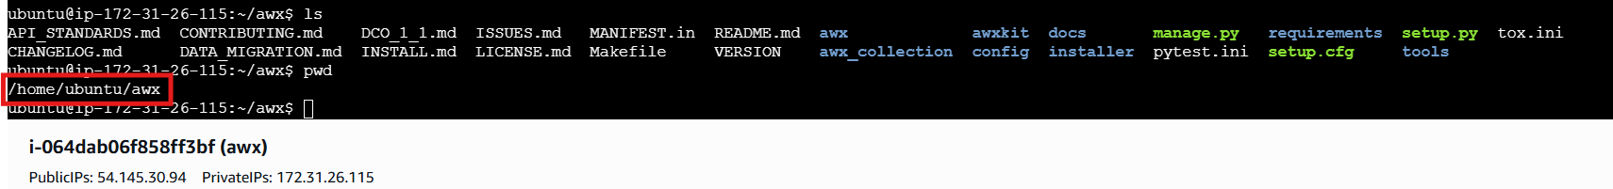
Cd installer
Ls
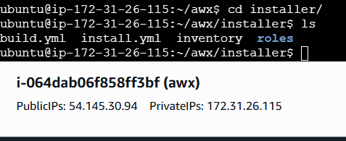
Run the playbook
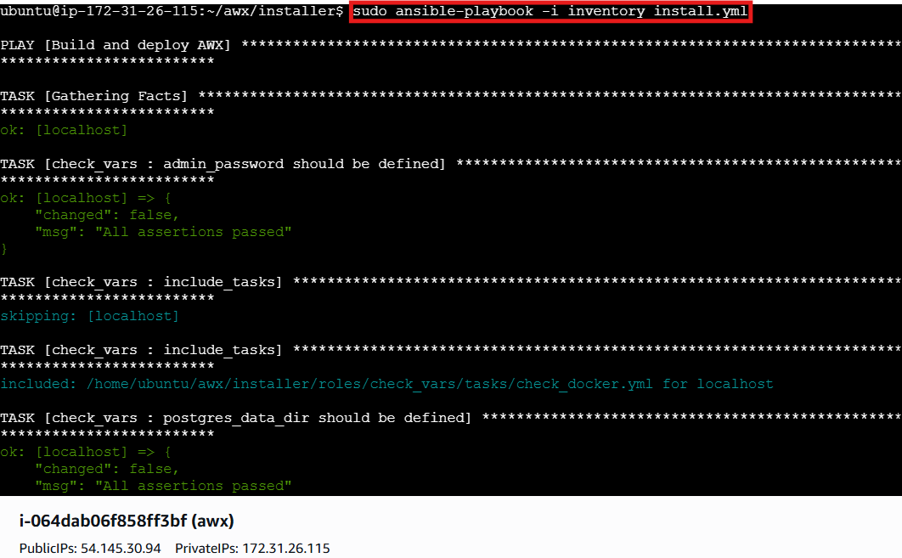
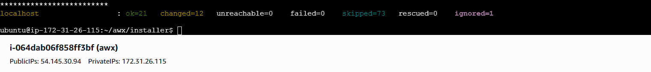

Check docker containers:
Docker ps
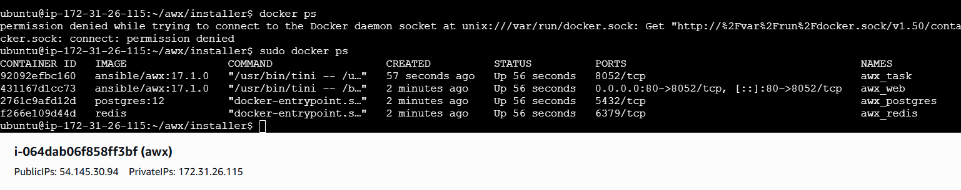
Open AWX in Browser
Open:
http://<EC2-Public-IP>
Login:
Username: admin
Password: (from inventory file)
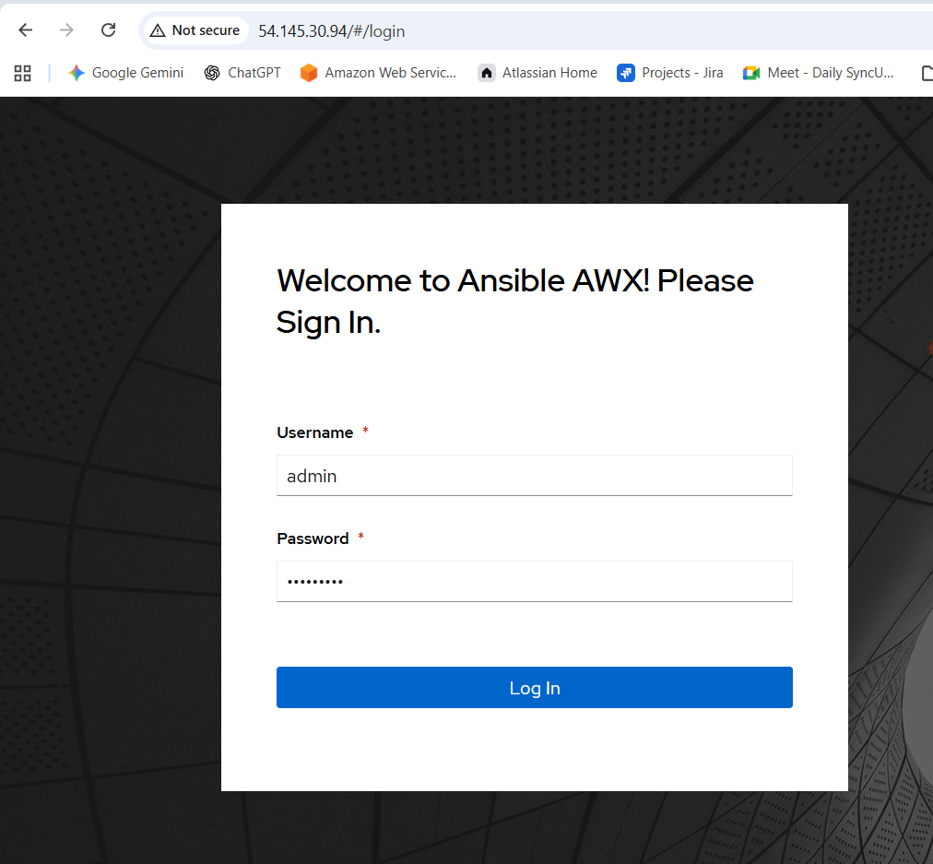
After login → Dashboard loads
AWX working
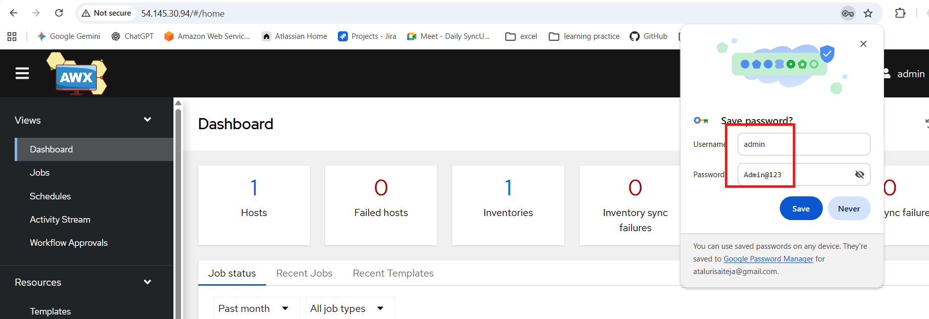

Verify Project
Go to:
Resources → Projects
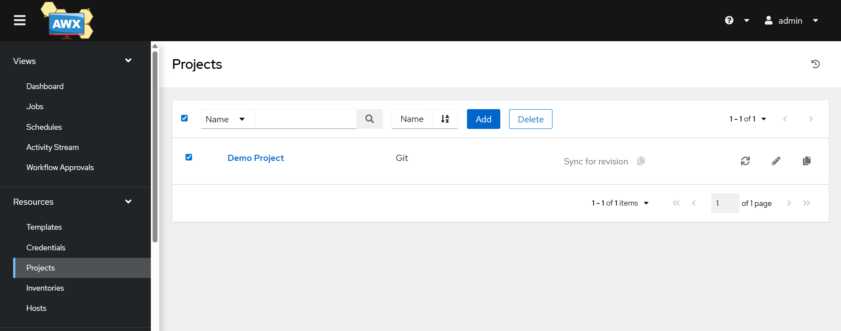
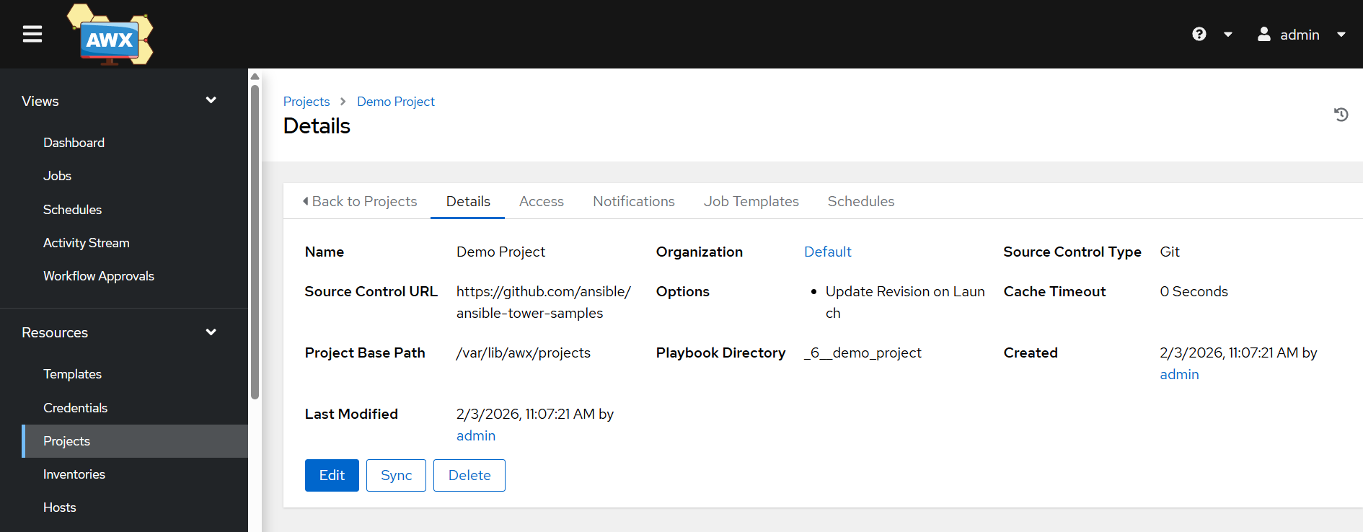

Go to:
Resources → Templates
Click on launch
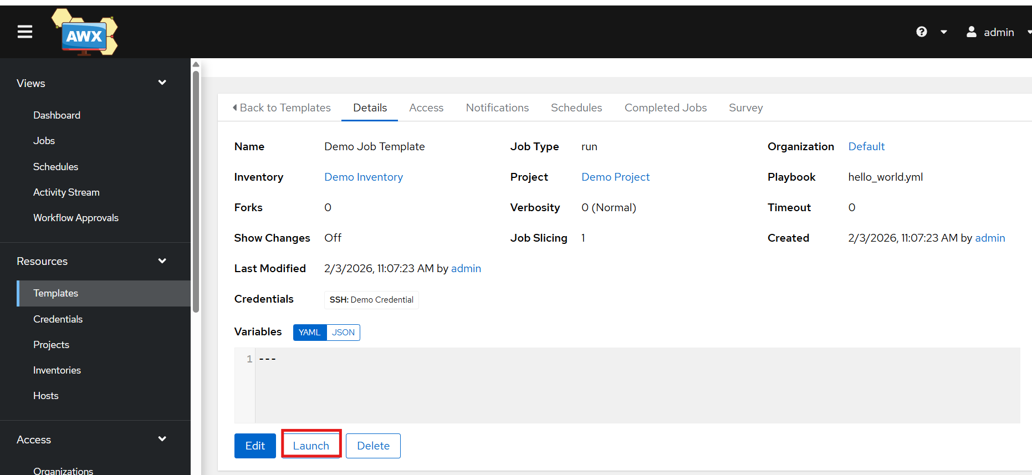
Its running
View Output
Go to:
Jobs → Select Job → Output
You will see:
Hello World
